The idea
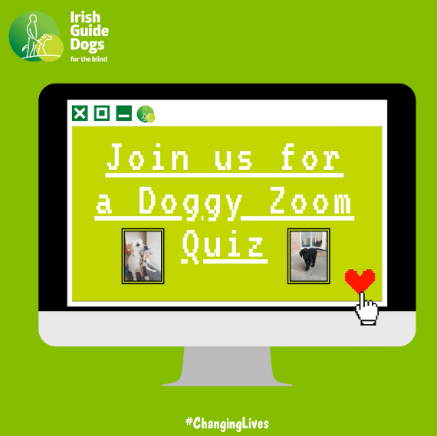
Zoom quiz nights have really taken off over the last few months as people get creative about how they spend time together whilst still staying apart.

We’ve developed a Doggy Zoom Quiz with various categories of wacky questions which would be great fun for family and friends who want to put their canine knowledge to the test. You could play for pride or liaise with local businesses to see if they might donate a prize for the winner.

If you are inviting the local community to get involved you could try following the below steps.

- Nominate your Branch Quizmaster.
- Select your date for the quiz and set up a Facebook Event on your Branch page. You can pin the event on the top of your Facebook page for visibility.
- Promote your event. (See tips below)
- Send entrants the Zoom quiz link. For example:

Thank you for entering our Doggy Zoom Quiz. We are looking forward to seeing you next Friday and hope it will be lots of fun. Please see below link to our JustGiving page where we will ask you to make a €5/€10 donation so that Irish Guide Dogs for the Blind can continue #ChangingLives.

- On the day, the Quizmaster calls out the questions – the participants write down their answers, and then at the end the quizmaster calls out the answers and the participants tot up their scores.
- Afterwards, email players to thank them for participating, reinforcing the idea that their involvement will help the charity to continue our work changing lives and suggest that if they are interested in getting involved in volunteering with your Branch to get in touch. Ensure to include a contact name and number.

When
Your Branch can run this event whenever suits you and your Volunteers. All you need is a quizmaster and some willing participants. Each Branch member could give it a bash with their own family and friends, or you could pick a date to host a quiz and invite local community supporters to get involved. If you haven’t yet used Zoom, we have a How to Guide available. We can help you do a test run and make sure you have everything ready before you have your actual quiz.

Income
You can set up a JustGiving page which all participants can donate to. We would suggest each participant donates a minimum of €5 to get involved! Instructions on how to set up a JustGiving page are detailed in our Facebook Guide which has been distributed to all Branch Chairs.

Promoting
- Post details on your Branch Facebook page which will be key to promoting your event. Having some planned content (video or photo updates) will help boost your fundraising efforts.
- Spread the word amongst your Branch Volunteers and Members encouraging them to get involved but also to ask them to drum up support within their own family, friends, neighbours, colleagues etc.
- If you know families who regularly have a family zoom quiz, why not promote it to them?
- Place posters in local shops and businesses.
- Get in touch with local dog groomers and vets and ask them to spread the word.
- Contact local community groups and online Facebook pages and ask them to promote the event.
- Using the Event notice template send details of your fundraiser to local radio stations and newspapers.

Sample social media posts
- It's quiz time!!! We are calling all Dog Lovers to take part in our Doggy Zoom Quiz which is taking place on [insert date and time].

Time to put your canine knowledge to the test and see how much you really know about man’s best friend, whilst raising funds for Irish Guide Dogs for the Blind.[tag IGDB]

To get involved, donate a minimum of X to our JustGiving fundraiser [insert fundraiser link] and comment here to let us know. We'll then send you further details.
All dogs are welcome.

#ChangingLives #DoggyQuiz4IGDB #PhoneAFurryFriend

IMAGE DESCRIPTION: [INSERT PHOTO]

- Fingers and paws on the buzzers. It's quiz time for Irish Guide Dogs for the Blind. [tag IGDB]
We are calling all Dog Lovers to join us on Zoom [insert date and time] for some good fun and a bit of a giggle.
To get involved, donate a minimum of X to our JustGiving fundraiser [insert fundraiser link] and comment here to let us know. We'll then send you further details.
#ChangingLives #DoggyQuiz4IGDB #PhoneAFurryFriend

Image description: Ambassador Dog Riley sitting on a pavement looking at the camera. [INSERT PHOTO]

Supporting material
Your Regional Development Co-ordinator will be happy to provide you with supporting material including:
- A quiz sheet
- Guide to setting up a Zoom link
- Campaign poster
- Social media campaign imagery
- Event notice template for distribution to local media and community

Thank you for everything you do to support us #ChangingLives

