Job Description
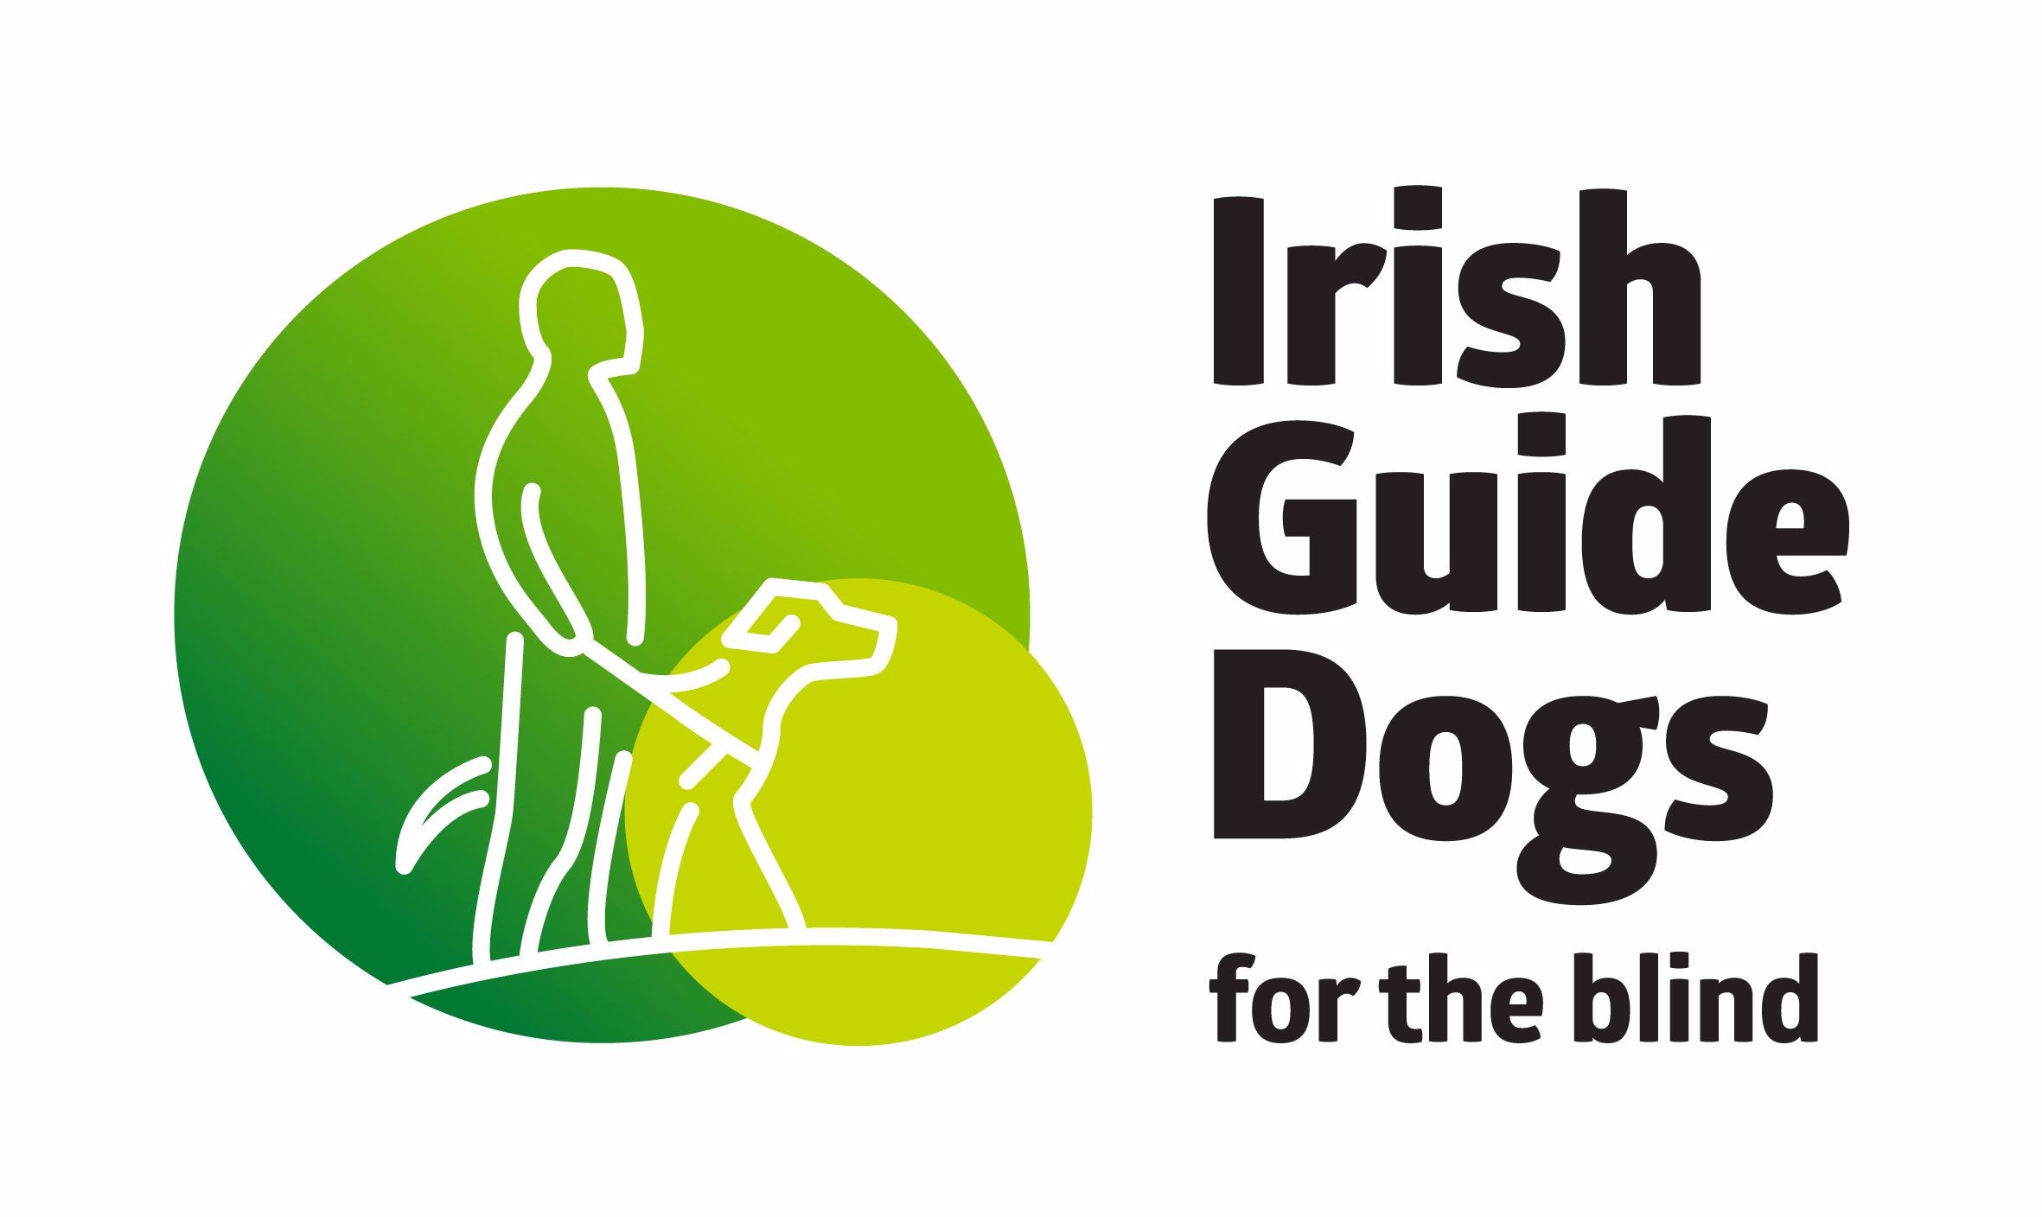
Job Title:  Qualified Assistance Dog Instructor | Department:  Technical Training Team | Reports to:  Assistance Dog Programme Manager
Hours:  35 hours per week | Location:  National Headquarters and Training Centre, Model Farm Road, Cork | Contract: Maternity Cover
Purpose of Role
An Assistance Dog Instructor provides specialist training of Assistance Dogs and training for children with autism and their families. The training provided ensures the dogs achieve the required standard to go to class and graduate to working status. The Assistance Dog Instructor also provides specialist training and aftercare support to Clients to ensure the safe and proper working of the created partnership.
Kay Responsibilities
- Carry out required preliminary assessments.
- Prepare selected dogs according to the pre-determined programme to ensure that dogs are supplied within desired time frame and quality standards. This includes ensuring dogs are class ready and appropriate matches are identified.
- Works with the Technical Lead in planning and completing all post-class, follow up and aftercare visits in a timely manner. This includes maintaining and documenting accurate records.
- Identifies temperamental and behavioural issues and ensures the application of appropriate solutions. Highlights all health issues and promptly refers them to be reviewed.
- Works with the Support Officer Lead and team to ensure strong confident Guide Dog partnership matches. Reports all appropriate matches and details to the Client Service Administrator in the approved time frame to ensure Clients are informed of any call to class in a timely manner.
- Maintains accurate and up to date records for dogs in their charge.
- Maintains regular and appropriate communication with Puppy Raisers to update on the dogs’ progress.
- Supports a ‘one team’ approach and builds effective relationships with all stakeholders such as supporting fundraising initiatives.
- Assists in training new staff, students, Puppy Raisers, apprentices, Guide Dog Mobility Instructors, and others as required and assigned.
- Compliance with agreed reporting processes to maintain accurate data and quality control standards.
- Any other duties as outlined by your line manager from time-to-time.

In addition to these key accountabilities, you may also have ownership for one or more key processes which will be communicated to you via your manager and/or the Performance Management framework.

Values and Behaviours
IGDB places great emphasis on how people get the job done. For example, we need people who are passionate about enabling people who are vision-impaired and families of children with autism to lead better lives and become more mobile and independent. Employees must achieve these standards to fully meet the expectations of their role.

Values and behaviours | Description
Respect | Treats Clients, Colleagues and Volunteers with equal respect.  Is open-minded and tolerant of different views.
Teamwork | Supports a team environment which promotes wellbeing and maximises personal effectiveness.  Communicates clearly and effectively with others.  Strives to be supportive, consistent and professional with Clients, Colleagues and Volunteers.
Optimism | Is solution-focused and looks to bring a positive attitude to challenges. Celebrates wins and encourages others to do the same. Does not fear failure – believes we can all learn lessons for the next time together.
Conscientiousness | Takes pride in what is done and how it is done.  Always presents a professional and capable manner in all tasks that are completed.  Has a clarity of purpose, sets a good example for others.  Is accountable for what is done and takes ownership for achievement.
Integrity | Leads by example.  Is fair and consistent when working with Clients, Colleagues and Volunteers. Takes ownership of achievements and responsibility for failure.
Excellence | Strives to continuously improve own performance.

Experience, Education and Skills

Essential:
- Qualified Assistance Dog Instructors only: Qualified instructor from an accredited body (ADI Accredited programme) with a proven track record of delivering key outputs.
- Proven track record for consistently meeting and exceeding goals and delivering a superior level of job performance.
- Very strong interpersonal skills with the ability to build relationships with all stakeholders.
- Strong team player, excellent communication skills and solution focused.
- Competent in Microsoft Office and great attention to detail.

Desirable
- Animal care qualification or equivalent qualification in a relevant discipline such as nursing/ psychology/occupational therapy.
- Qualified in teaching or mentoring in an associated field.
- Practical experience working with dogs within either dog care or training environment.
- Evidence of continued professional development to enhance knowledge and experience relevant to the role.
- Experience of a least one aspect of the disability sector.

Special Conditions
- Full clean driving license essential.
- Must be eligible to work in Ireland and EU.
- Full Garda (Police) vetting including any time spent overseas.
- Physically able to complete the work required and perform tasks that require manual handling techniques such as lifting, pulling, pushing, etc.
- Physically able to work outdoors all year round in all weather conditions (as approximately 50% of role will be completed outdoors).
- Ability to work evenings, weekends and unsociable hours as required and an acceptance of the need to travel nationwide as part of the role. Please note that you will be required to work approximately 12 weeks per year (a maximum of 3-week duration per incidence) away from the Centre where you will need to stay overnight depending on location.

To apply, please send the below information to Recruitment@GuideDogs.ie
• Up-to-date CV
• Cover letter

The closing date for applications is Thursday 13 October 2022.

Irish Guide Dogs for the Blind is an equal opportunities employer

